Analysing Data

# Validating Cell Detection Results

1. Open a file for processing (*File > Open*) from \\ibtfilesrv2\microscope\Stefan\DFG\
2. Check the last frames of the sequence for the filling level. If the chamber is too full (to your opinion) duplicate the image (which can be used for cropping it in time dimension):
   * *Image > Duplicate* (or hit Ctrl+Shift+D)
   * Select the previously determined last frame of the final sequence and put it in the *Frames (t)* field as last frame
3. You should see the cells encircled with yellow lines denoting detected cells in the automatic processing. In order to be able to work with them, enable the labels: open *Images > Overlay > Labels…* and select the Color (white works well) which will also check the Show Labels box automatically (if not, do it manually)
4. You can now edit the generated results:
   * Delete a cell: Select a cell (click the label) and hit backspace to delete it
   * Add a cell: Select a region of interest and click the A in the toolbar (or hit a on the keyboard; if this doesn’t work go to Installing Macros)
   * Split a cell:
     1. Activate the splitting tool by opening *Plugins > MASTER PLUGIN.* Uncheck everything and click *Start*.
     2. Once the splitting tool is active you can select ROIs by clicking on them.
     3. Click outside of the selected ROI to set the beginning of a split (that will be shown interactively). Holding down the mouse button shows the split interactively, so just cross the select ROI as you wish and release the button when you are satisfied
   * Connect two cells:
     1. Activate the splitting tool and focus the image (click the titlebar)
     2. Hold down shift and click two neighboring ROIs
5. Using the previously described tools, go through the sequence (**HINT:** you can go to the next frame by pressing Ctrl+🡪). If you have questions, contact me immediately!
6. Once you are satisfied save the resulting file to the network share, appending *_1-70_final* (when 70 is your last frame) in front of the file extension

# Executing Tracking and Validating Results

1. Open *Plugin > Tracking > TrackMate* (the windows that opens will guide you through the process)
2. Set the *Time interval* according to the experiment, e.g. 480 sec for an experiment with 8 minutes imaging interval
3. Select the *Overlay Detector* and click *Next*
4. Click *Next*
5. Wait for the results to be processed and click *Next*
6. Click *Next*
7. Select the *HyperStack Displayer* (default) and click *Next*
8. Click *Next*
9. Select *LAP Tracker* and click *Next*
10. Scroll down and check *Allow track segment splitting*, decrease the *Max distance* to 7.5μm and start tracking by clicking *Next*
11. Click Next
12. In the display options window select the *Track display mode* to be *Show Local Tracks, forward* and set the *Frame depth* to 5.
13. Start the lineage view by clicking *Track scheme*
14. If you find a misassignment in the image sequence (by going through it frame by frame):
    * Find the correct assignment and select both pink dots (in the image windows) by holding Shift and clicking
    * Now open Track Scheme and right click in an empty space
    * Select *Link 2 Spots*
    * Now that the correct assignment is set, remove the connection to the old parent by selecting the edge and hitting the Del key
15. Once you are finished, save the results (click *Save*, which will open the file selection dialog) in a file that is named like image but with xml file extension (should be the default case…)

# Installing Macros

1. Go to *Plugins > Macros > Install*
2. Select StartupMacros.ijm in the Fiji.app/macros folder (which should be the default case…)

# What if I can’t see anything in the image?

If can’t see anything (or you only see a black image) it is very likely that some brightness or contrast settings have been determined incorrectly. Usually this is not a problem for phasecontrast but for the fluorescence channels.

You can correct this by setting the values manually. To do so open *Image > Adjust > Brightness/Contrast…*. You can see the distribution of values at the top of the window. If you image is all black it is very likely, that the right value below the distribution is very high (something like 65000). To change that value automagically just move the handlebar for the maximum value slightly to the left and back to the rightmost position. This will set both the minimum and the maximum value according to the currently shown image.

If you know your background fluorescence signal, you can move the minimum to that value (or a little higher). This will effectively hide pixels with signals lower than the minimum.

|  |  |  |
| --- | --- | --- |
|  |  |  |

Table 1. A) The location of the Brightness/Contrast tool in the menu structure. B) The distribution and values before any correction. C) After correcting the minimum and maximum values, respectively.

# Filters explained

Filters are used to determine if a detected cell is valid or if it has to be processed to generate a valid cell. A simple example is the size filter. It discards cells completely according to two cut off values, marks them for further processing if an object is unlikely to be a single cell, or detects the object as a single cell (in which case no further processing is done), respectively.

Further processing comprises the attempt to split up the objects meaningfully. In short, it searches for the two closest points on the objects contour and connects those points with the split line.

# How to determine values for filters

Several filters are already implemented for which there are different procedures to determine optimal parameters if possible at all:

Size Filter

The size filter offers three parameters:

*Minimal Cell Size*

Objects that are smaller than this threshold are discarded.

*Maximal Cell Size*

Objects that are smaller than this value will be regarded as single cells, thus, no further splitting mechanisms are applied.

*Background Size*

Cells that are smaller than this threshold but larger than the maximal cell size value are further processed. An algorithm is applied that tries to split up the cells since their size seems to be non-standard. Object larger than this value are discarded.

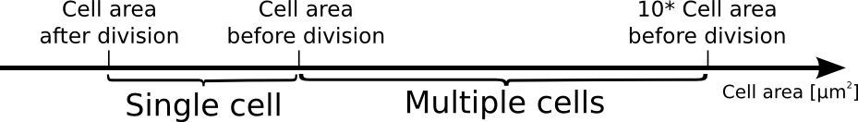

You can determine optimal values for you data by measuring

* Cell area after a division,
* Cell area before a division,
* Summing up a normal cell area times ten.

To do so:

1. Window of *Analyze > Set Measurements*
2. Tick the boxes as shown in the screenshot
3. Select a cell
4. Click *Analyze > Measure* or hit Ctrl + M
5. A results window will pop up and show the detected area

|  |  |
| --- | --- |
| A) | B) |
| C) |  |

Table 2. A) Window of *Analyze > Set Measurements*.. B) Select a cell. C) Results table generated by *Analyze > Measure*

Convex Hull Filter

Actually this filter should be called solidity filter. The idea is, however, the same: compute the convex hull of an object and compute the ratio of its area to the convex hull as shown in Figure X.

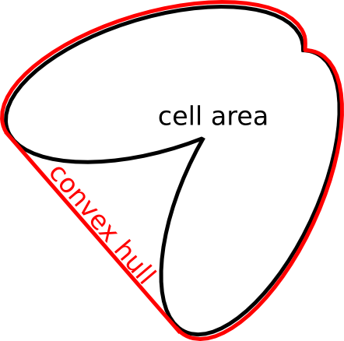

Table 3 xxx

Therefore, you should set the deviation value to about 0.20. The lower the value, the more perfectly shaped a single cell has to be in order to not be split.

Size and Convex Hull Filter combined

The idea is to filter small and large objects according to the minimal cell and maximal cell size, respectively. Consequently, the solidity filter is applied to the remaining objects.

No Filter

(not implemented yet..)

Shape Filter

(not implemented yet..)

# Update Sites

<http://ibtmodsimhub/imagej/jungle-dev> (current development version)

<http://ibtmodsimhub/imagej/jungle> (stable version)